Code4Kids Summer Coding Academy 2018
Student Guide
Welcome to the Code4Kids Camp! We are excited to see how you use your creativity and your knowledge to make interesting things this week.

We will continue to add new activities and tutorials throughout the year
at our website www.code4kids.me

Have questions? Feel free to email cody@code4kids.me any time

Table of Contents

Day 1 (Monday) 2
Goals for Day 1 (Monday) 2
Intro to Lightbot 2
Intro to Ozobot Evo 3

Day 2 (Tuesday) 5
Goals for Day 2 (Tuesday) 5
Line Following and Color Codes 5
Color Code Reference 6
Extra Color Code Activities 7
Intro to Lightbot Procedures and Functions 12

Day 3 (Wednesday) 13
Goals for Day 3 (Wednesday) 13
Intro to OzoBlockly Editor (ozoblockly.com/editor) 14
OzoBlockly Looping Example: Fashion Runway 15
OzoBlockly Functions and Variables Example: Rev Up 15

Day 4 (Thursday) 16
Goals for Day 4 (Thursday) 16
Driver-Less Car Course 16
Traffic Rules Course 16
Extra OzoBlockly Activity #1: Jumping (Level 4 OzoBlockly) 17
Extra Ozoblockly Activity #2: Piano (OzoBlockly Level 3) 18
Piano Extra Credit: Use Markers to Make Your Own Color/Note Combos to Play a Song 19
OzoBlockly Extra Activity #3: Avoid Red (OzoBlockly Level 3) 20
OzoBlockly Extra Activity #4: Snowplow 21

Day 1 (Monday)

Goals for Day 1 (Monday)
- Learn the basics of computer programming using the app “Lightbot”
- Learn how to control the robot (known as the “Ozobot Evo”) manually using the tablet

Intro to Lightbot
Lightbot is a free app that is available for iOS, Android, and even freely available on the web from a computer at lightbot.com. The basic idea is to move the robot around on the map turning on the “lights” (blue tiles).
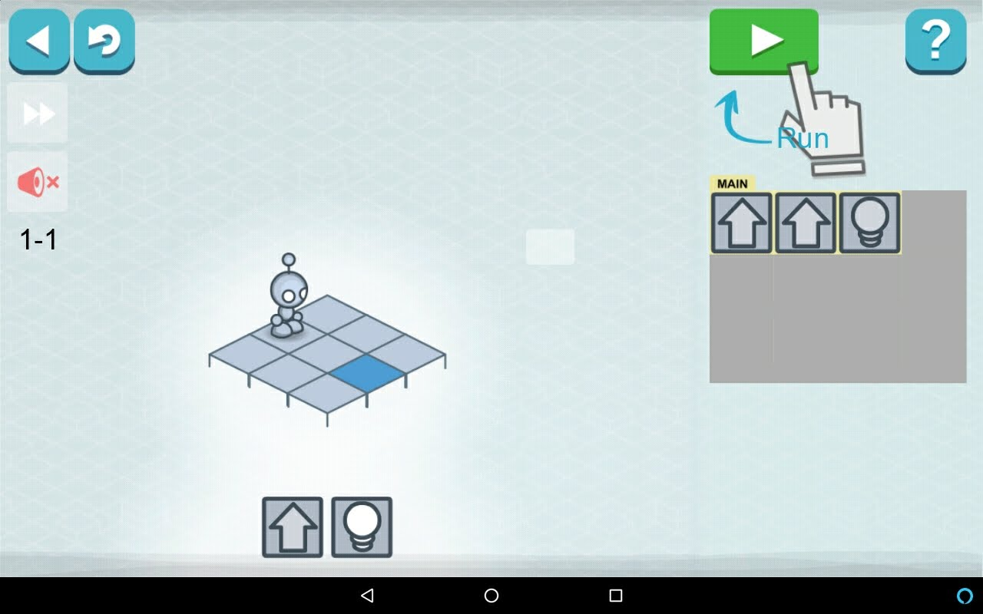

Intro to Ozobot Evo
The Evo is a powerful little robot – and you get to take it home with you at the end of camp! Today we are going to explore how to manually control the robot using the free Evo app (available for iOS and Android).
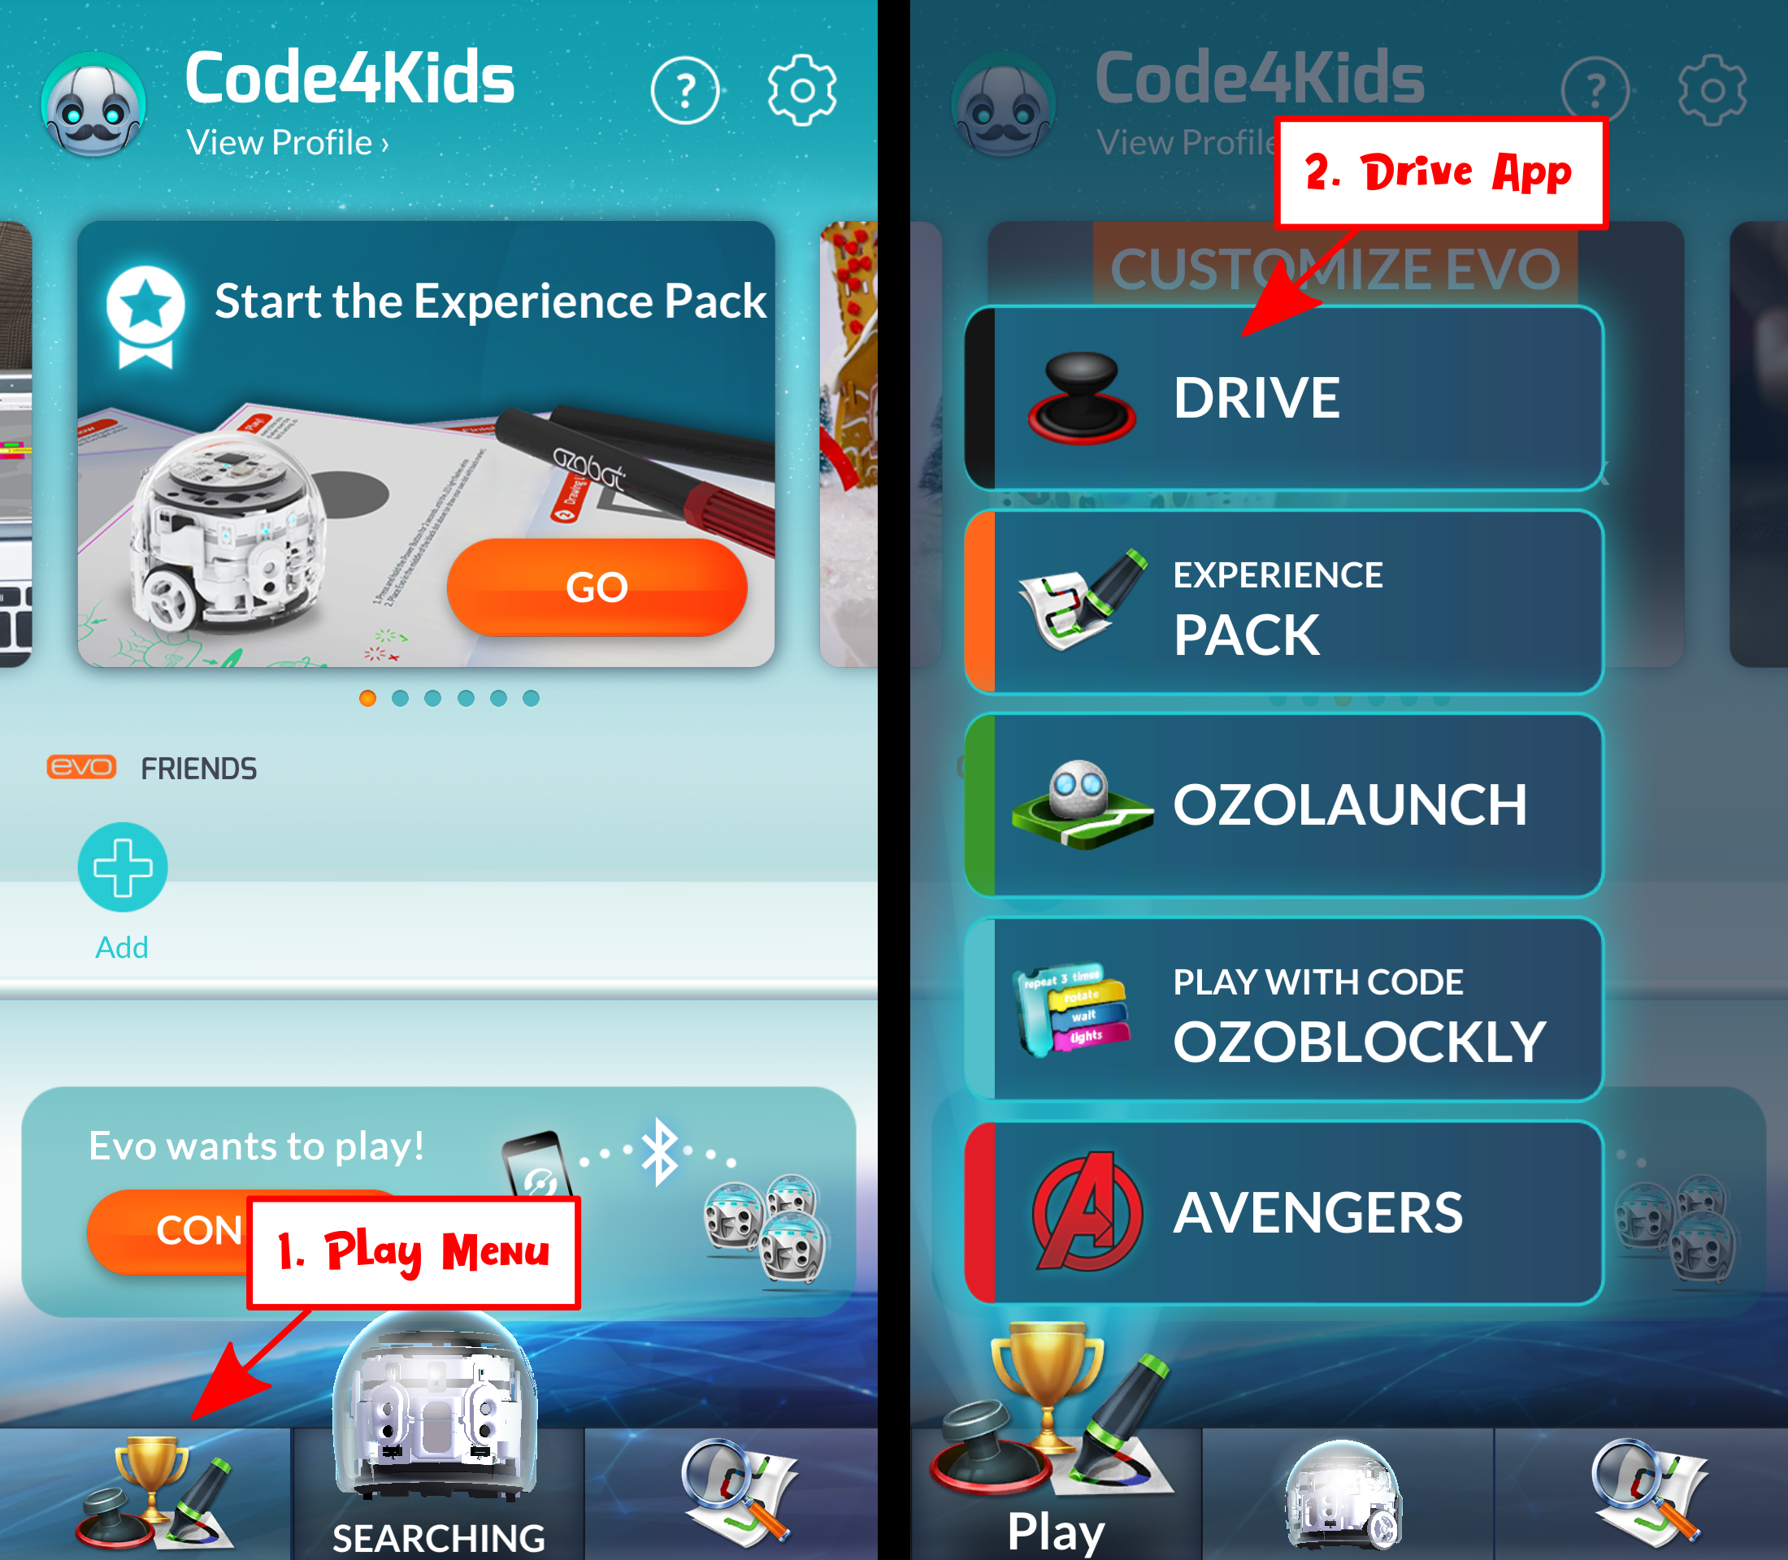
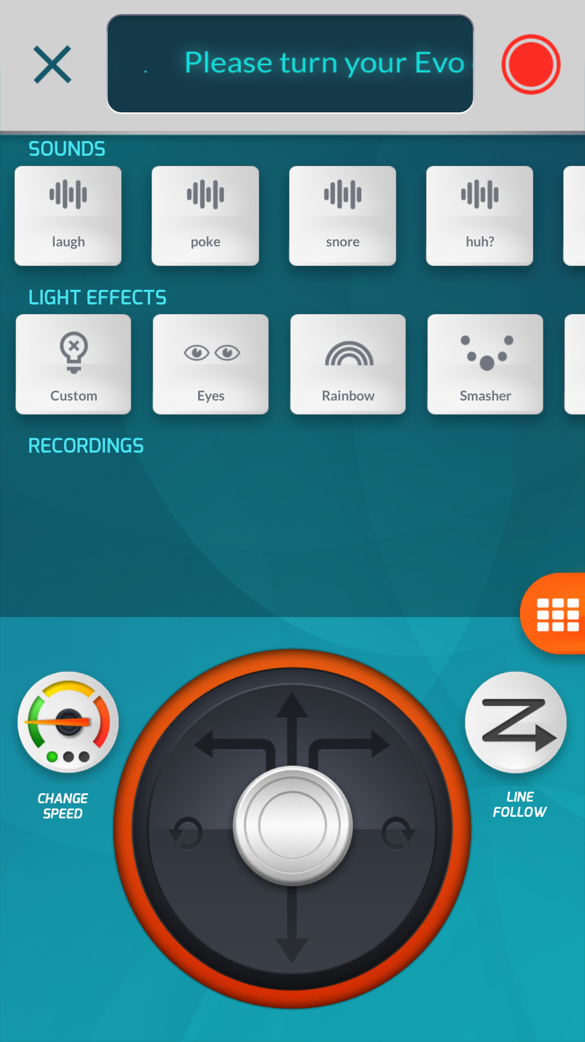
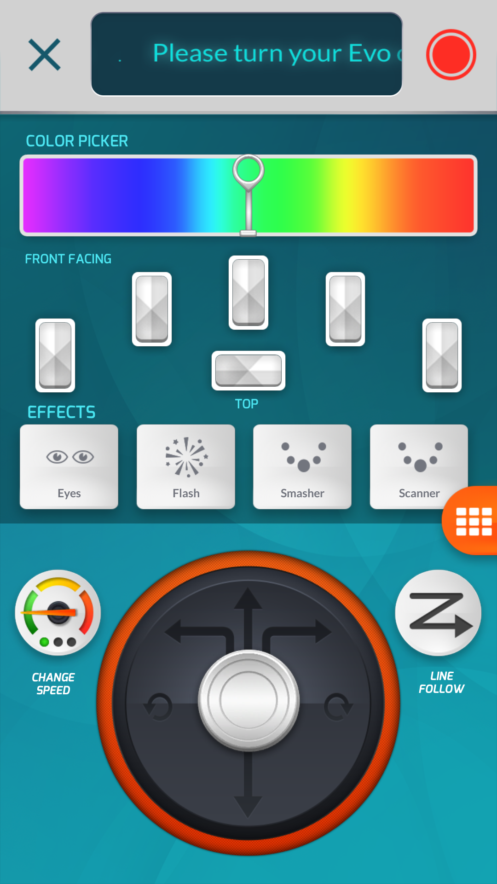
At the top you can see “Sounds” and “Light Effects.” The Evo has a large list of phrases and sounds it can make (only a few are shown here), and it can individually control several LED’s and even animate them. For more control over the LED’s, press the orange button with the grid halfway down on the right side of the screen.

Want a challenge? Figure out how to make all of the LEDs have different colors at the same time!

Day 2 (Tuesday)

Goals for Day 2 (Tuesday)
- Learn how the Evo follows lines on a page
- Learn how to control the Evo using Color Codes
- Understand how the Evo’s proximity sensors work
- Learn how to reuse code with Lightbot app

Line Following and Color Codes
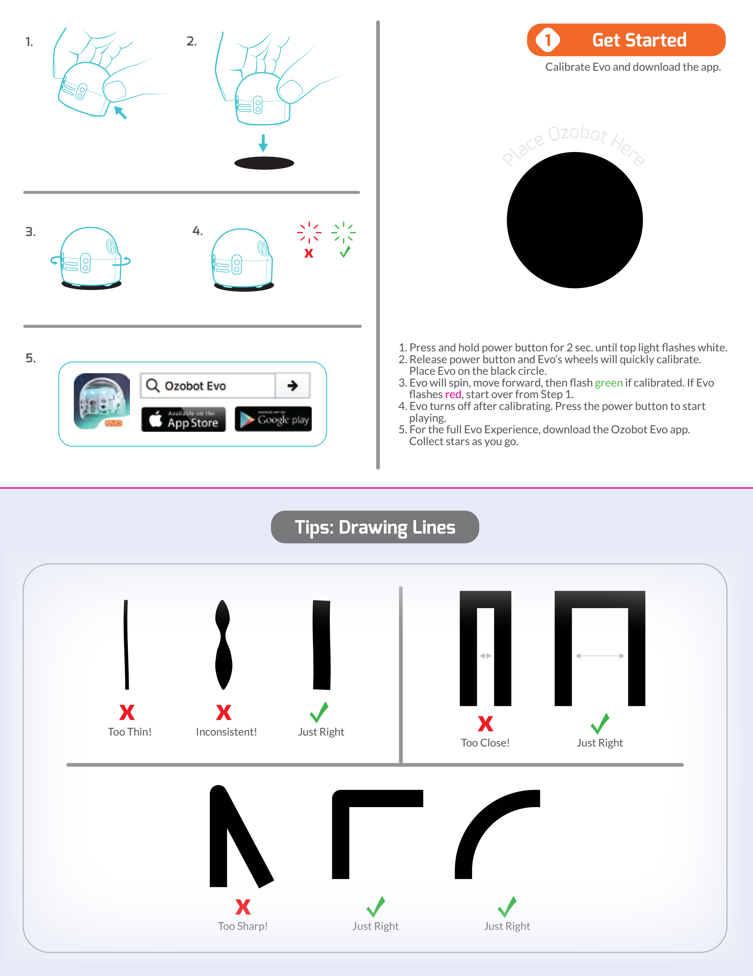

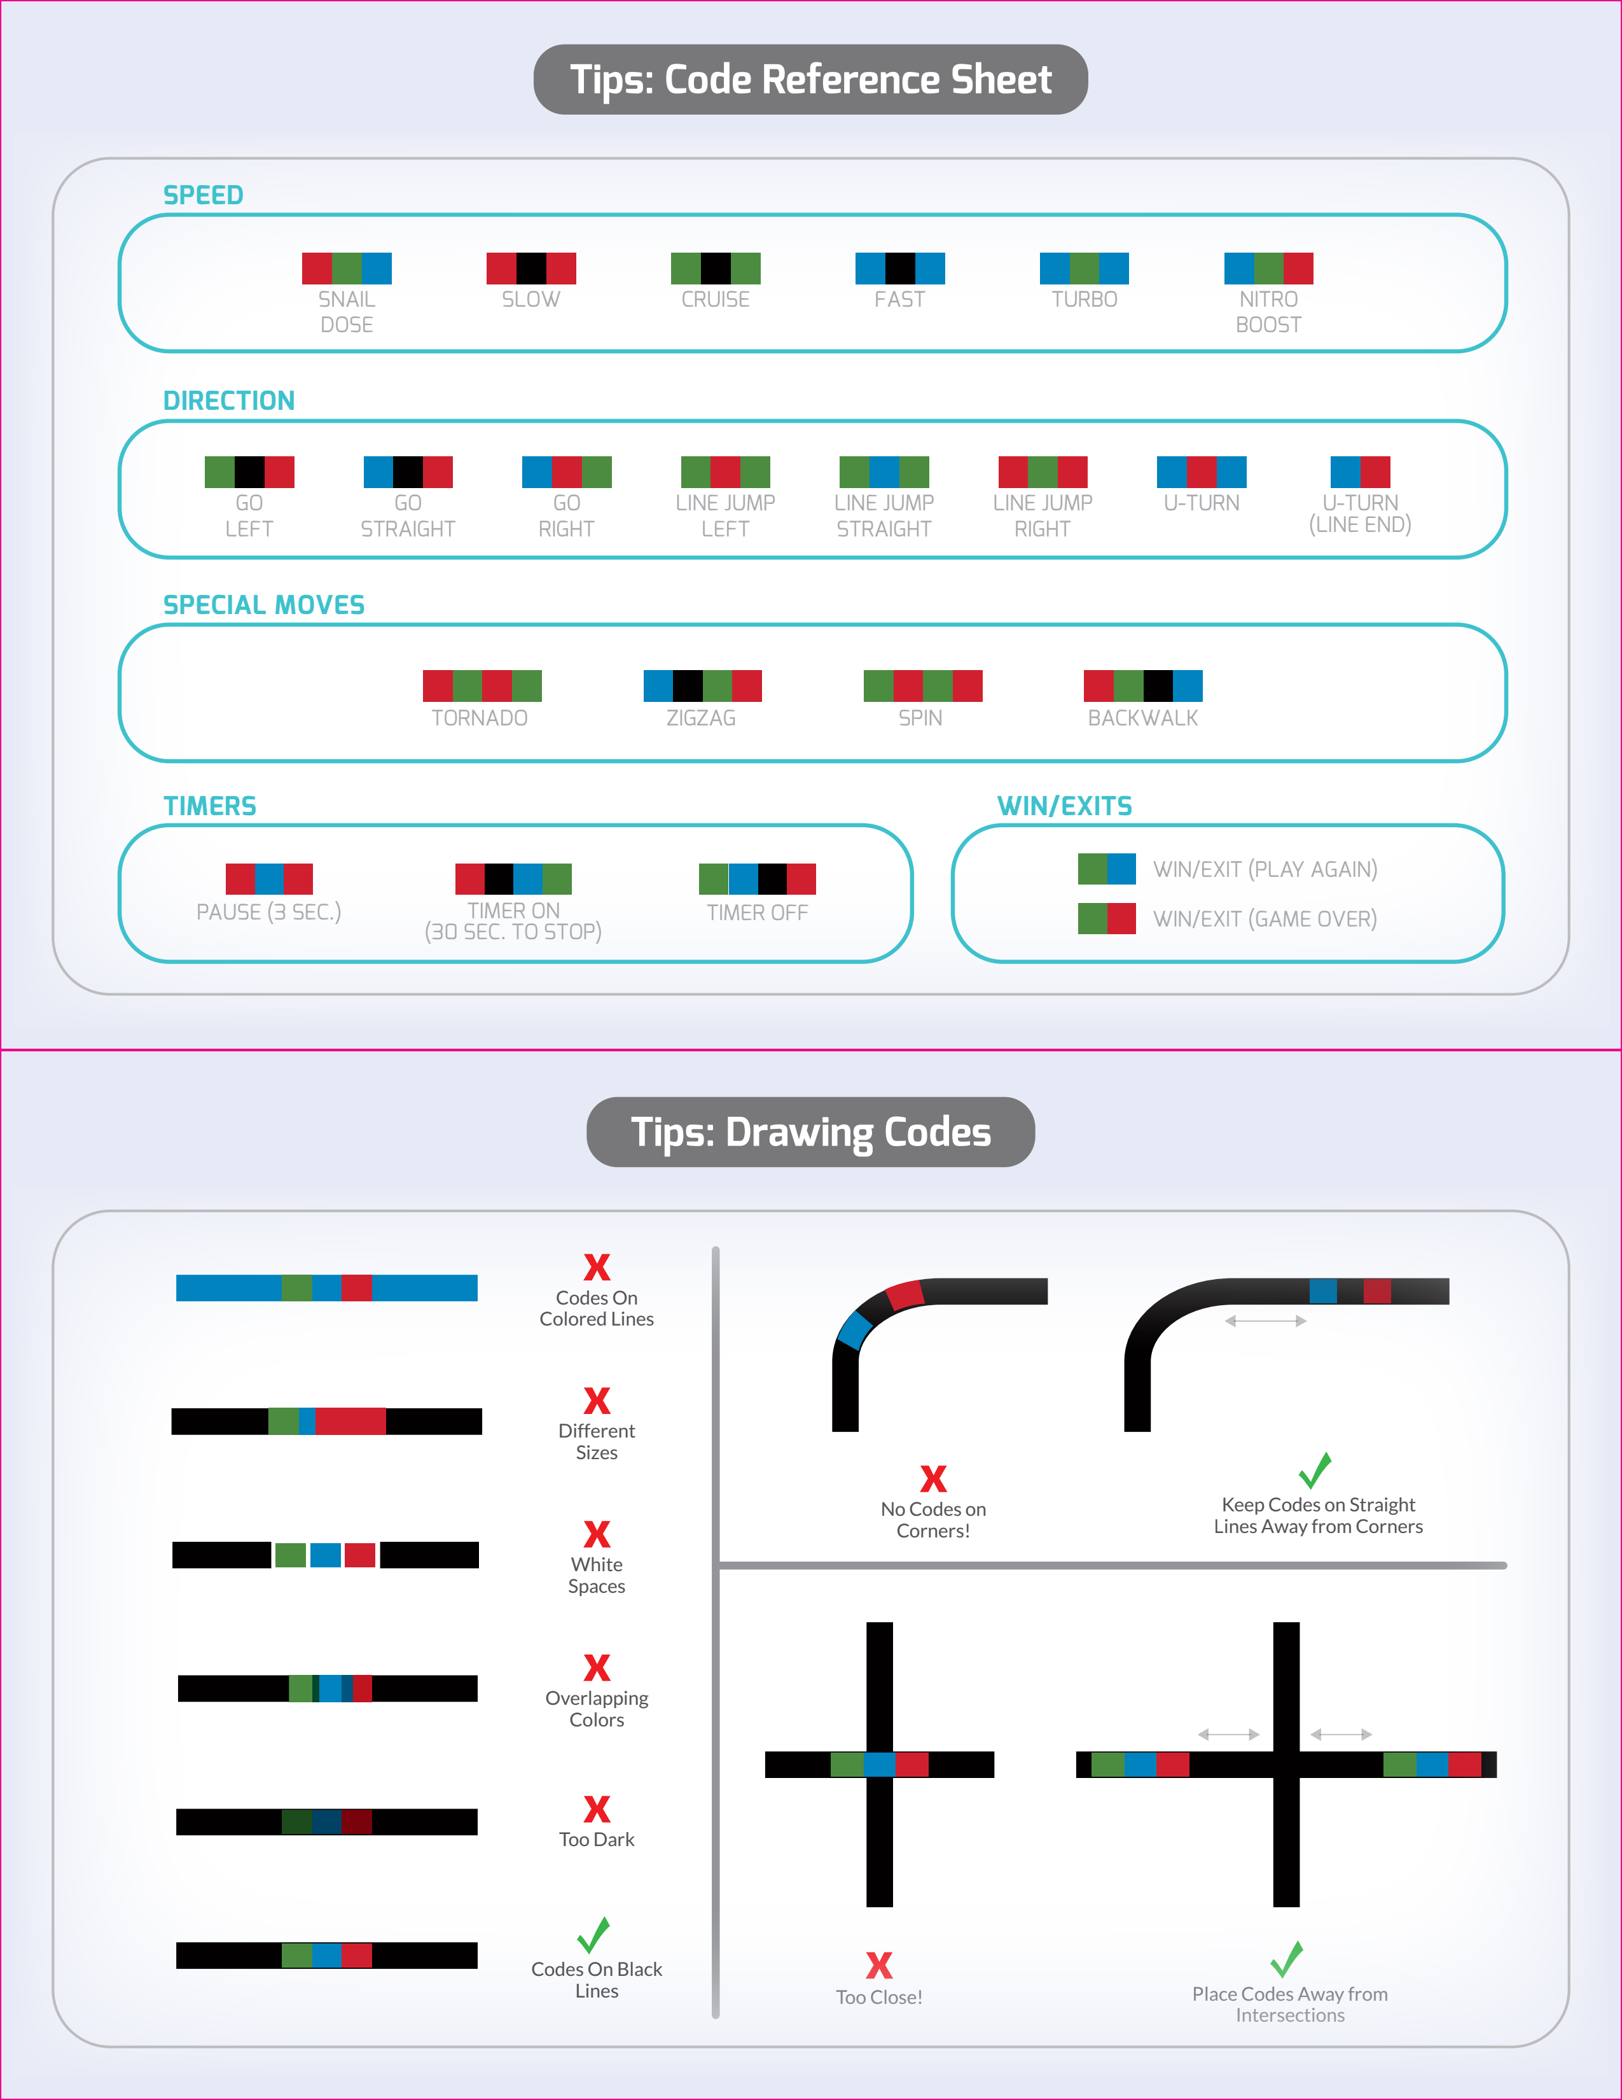
Color Code Reference

Extra Color Code Activities
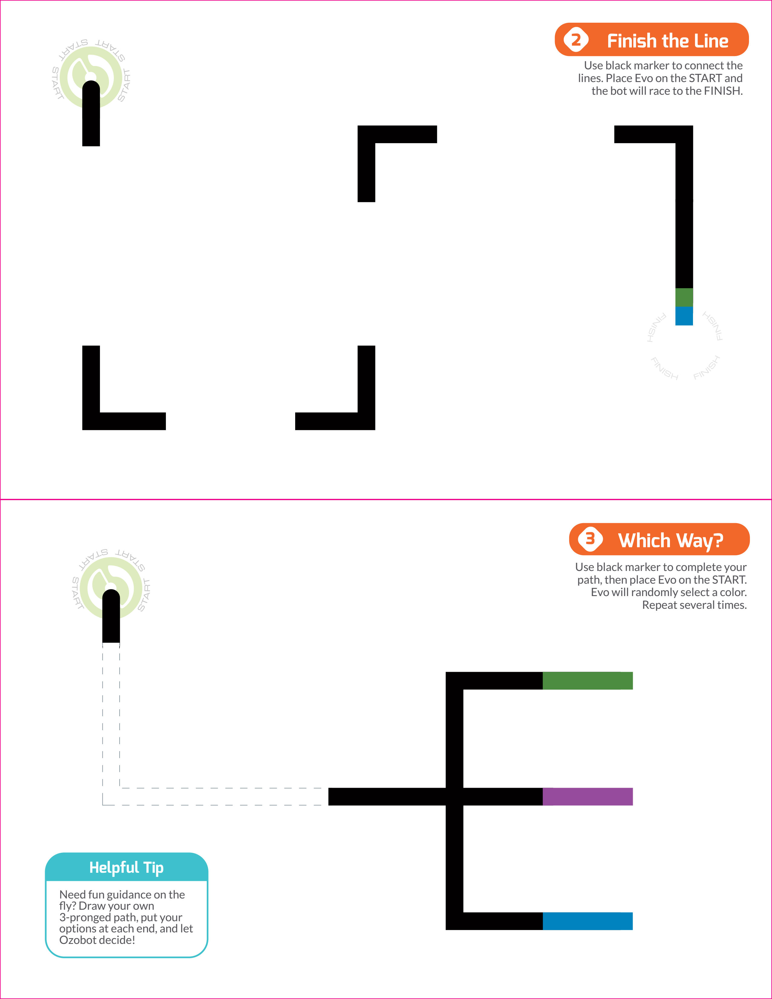
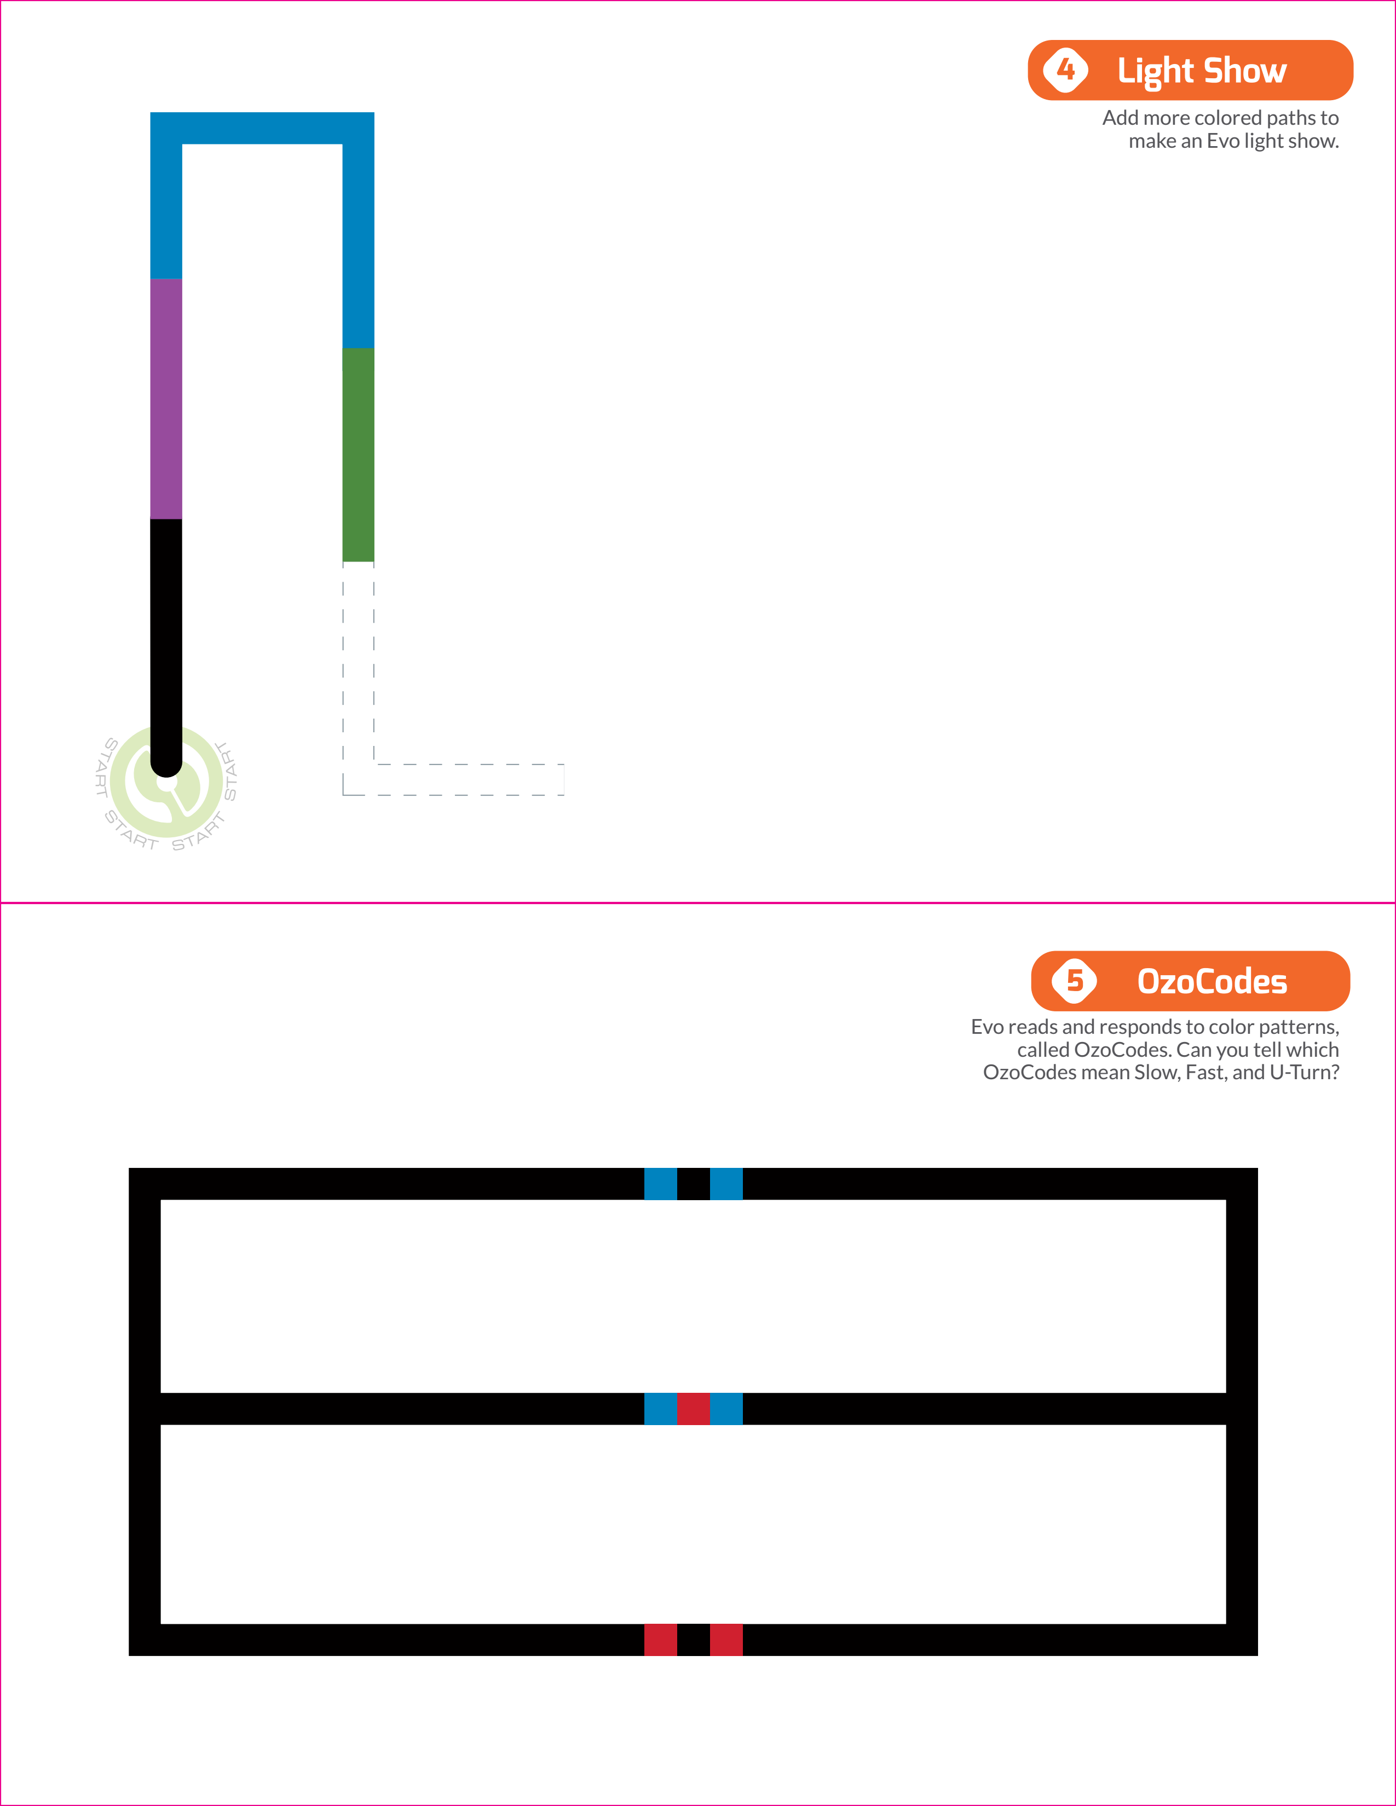
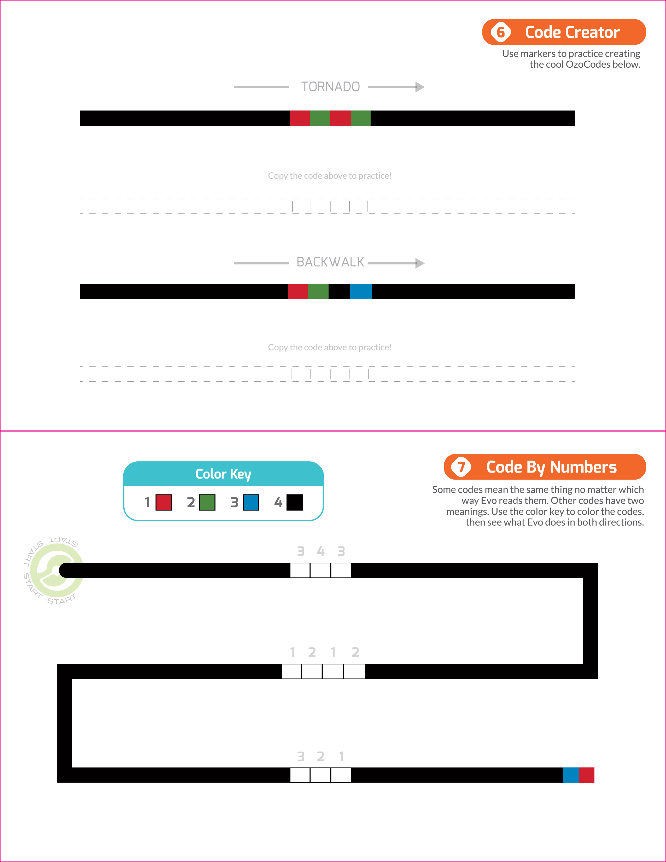
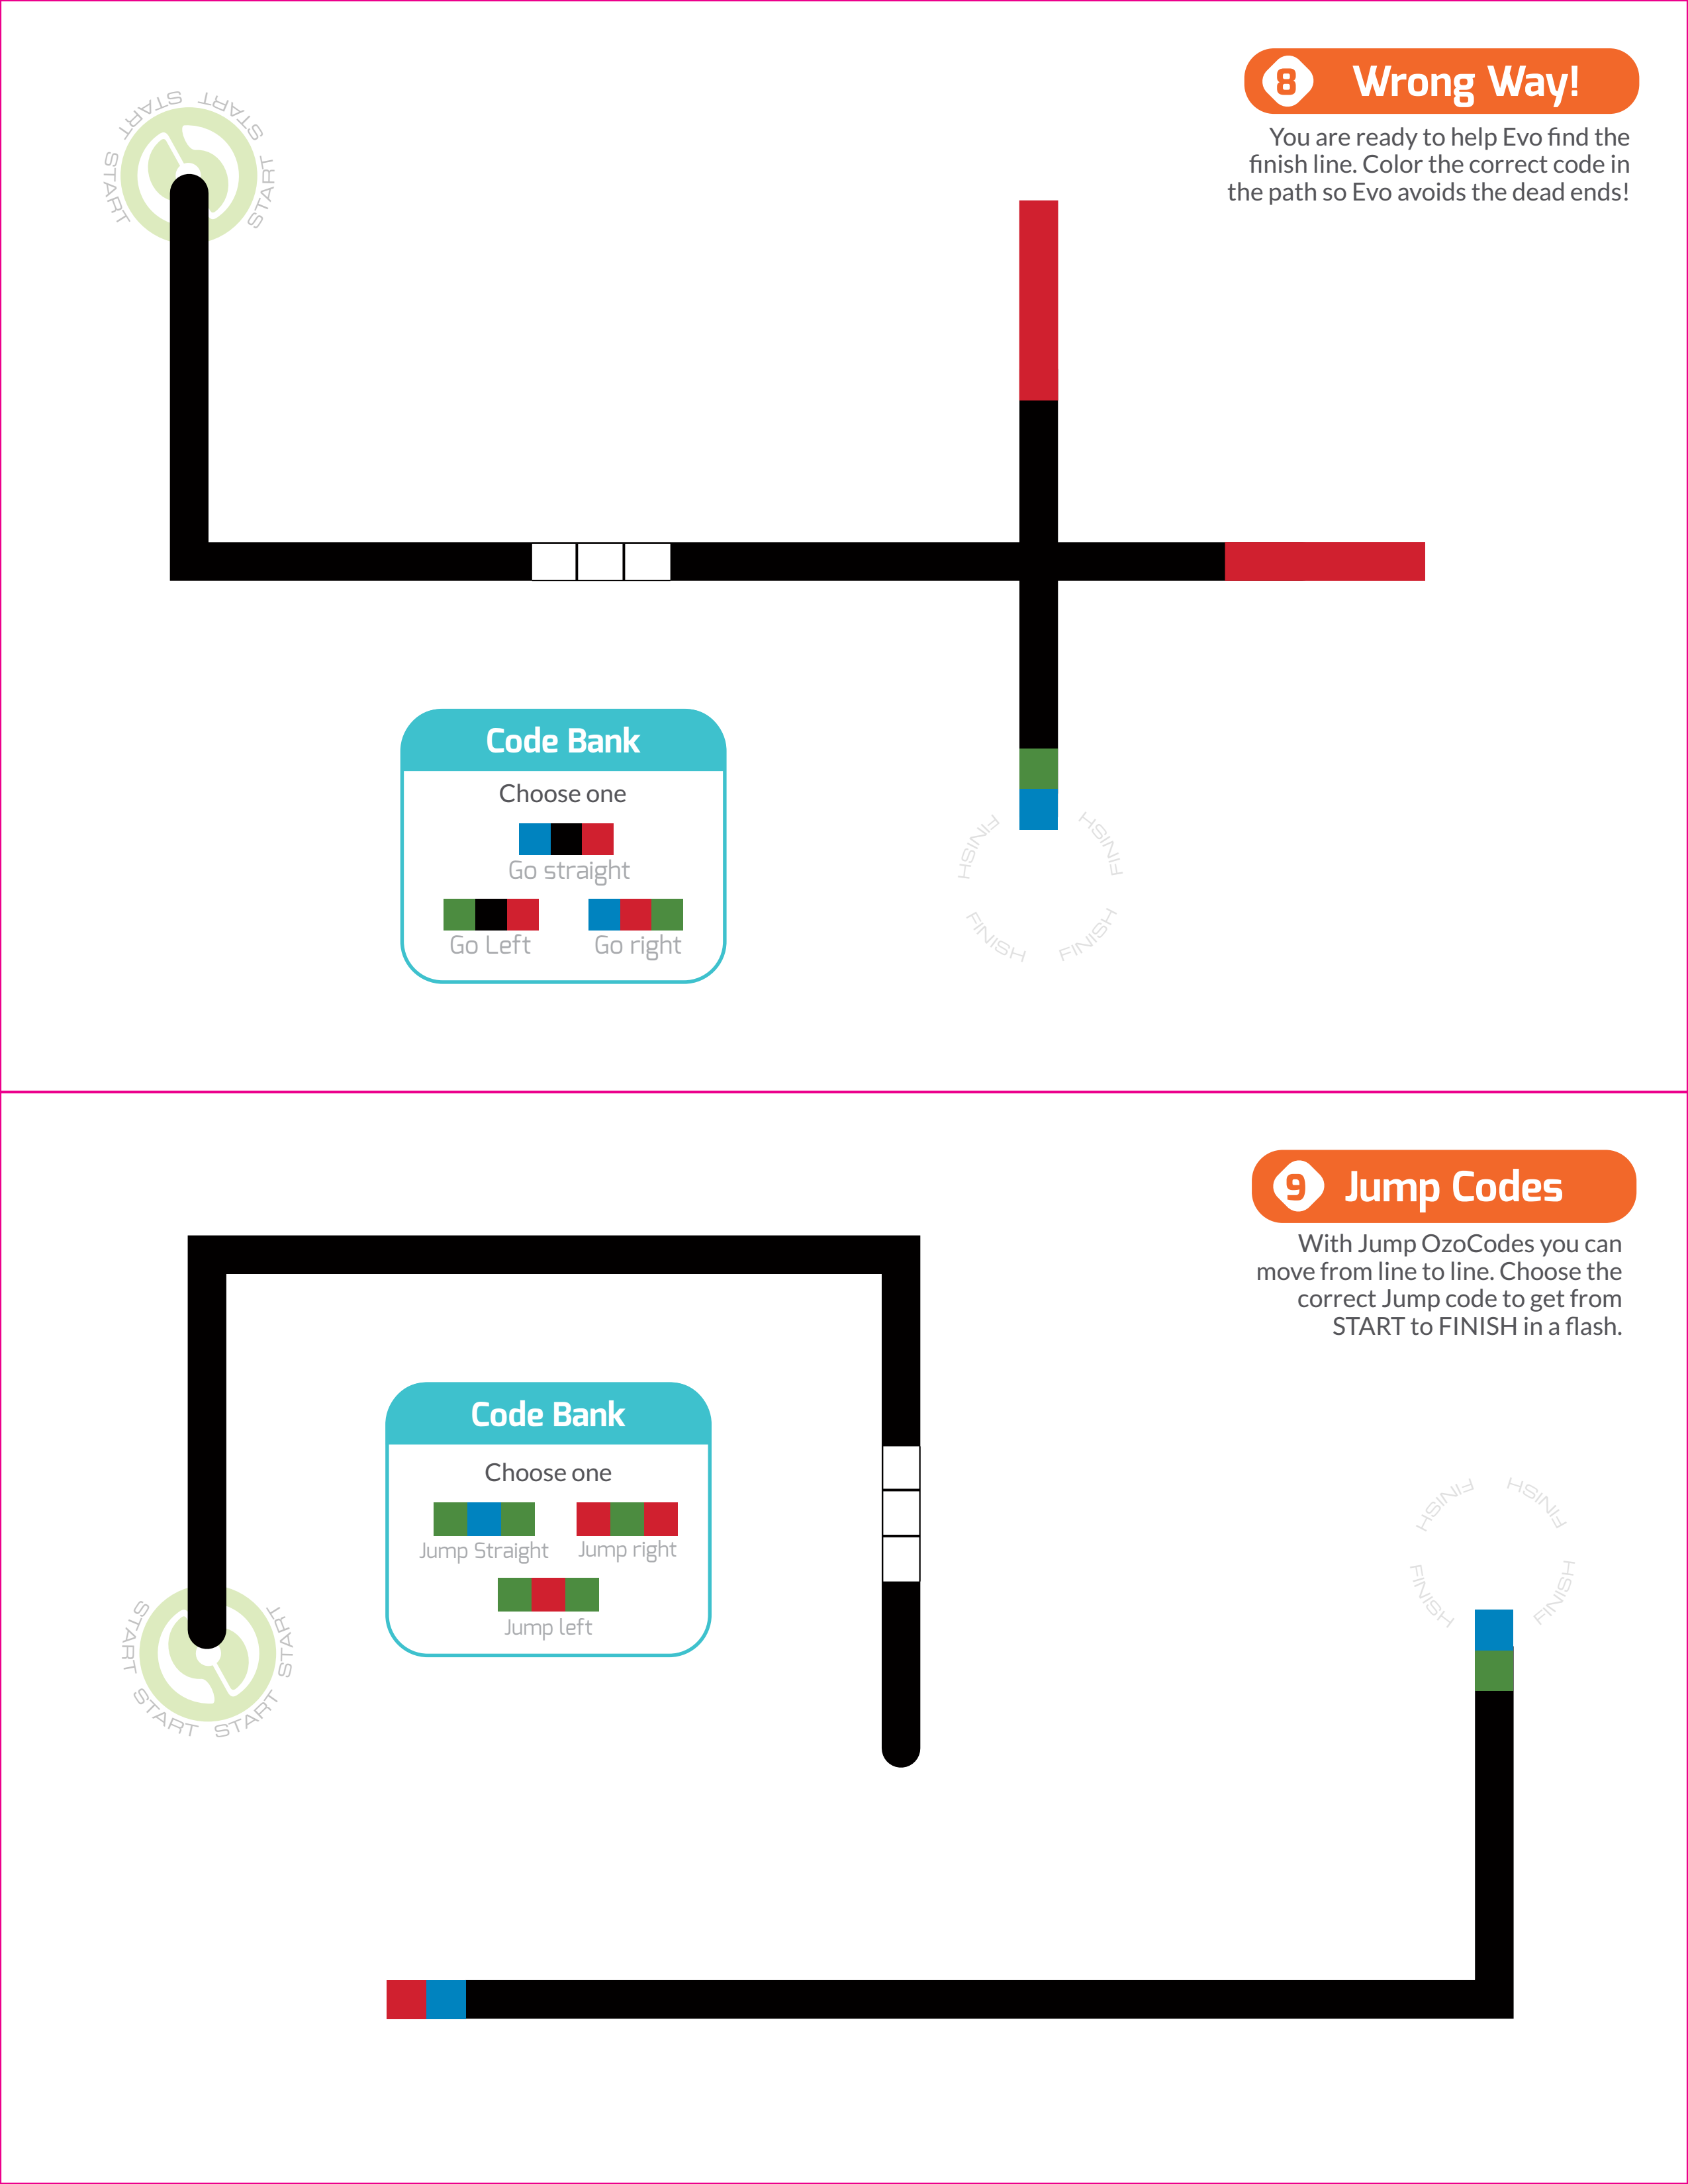
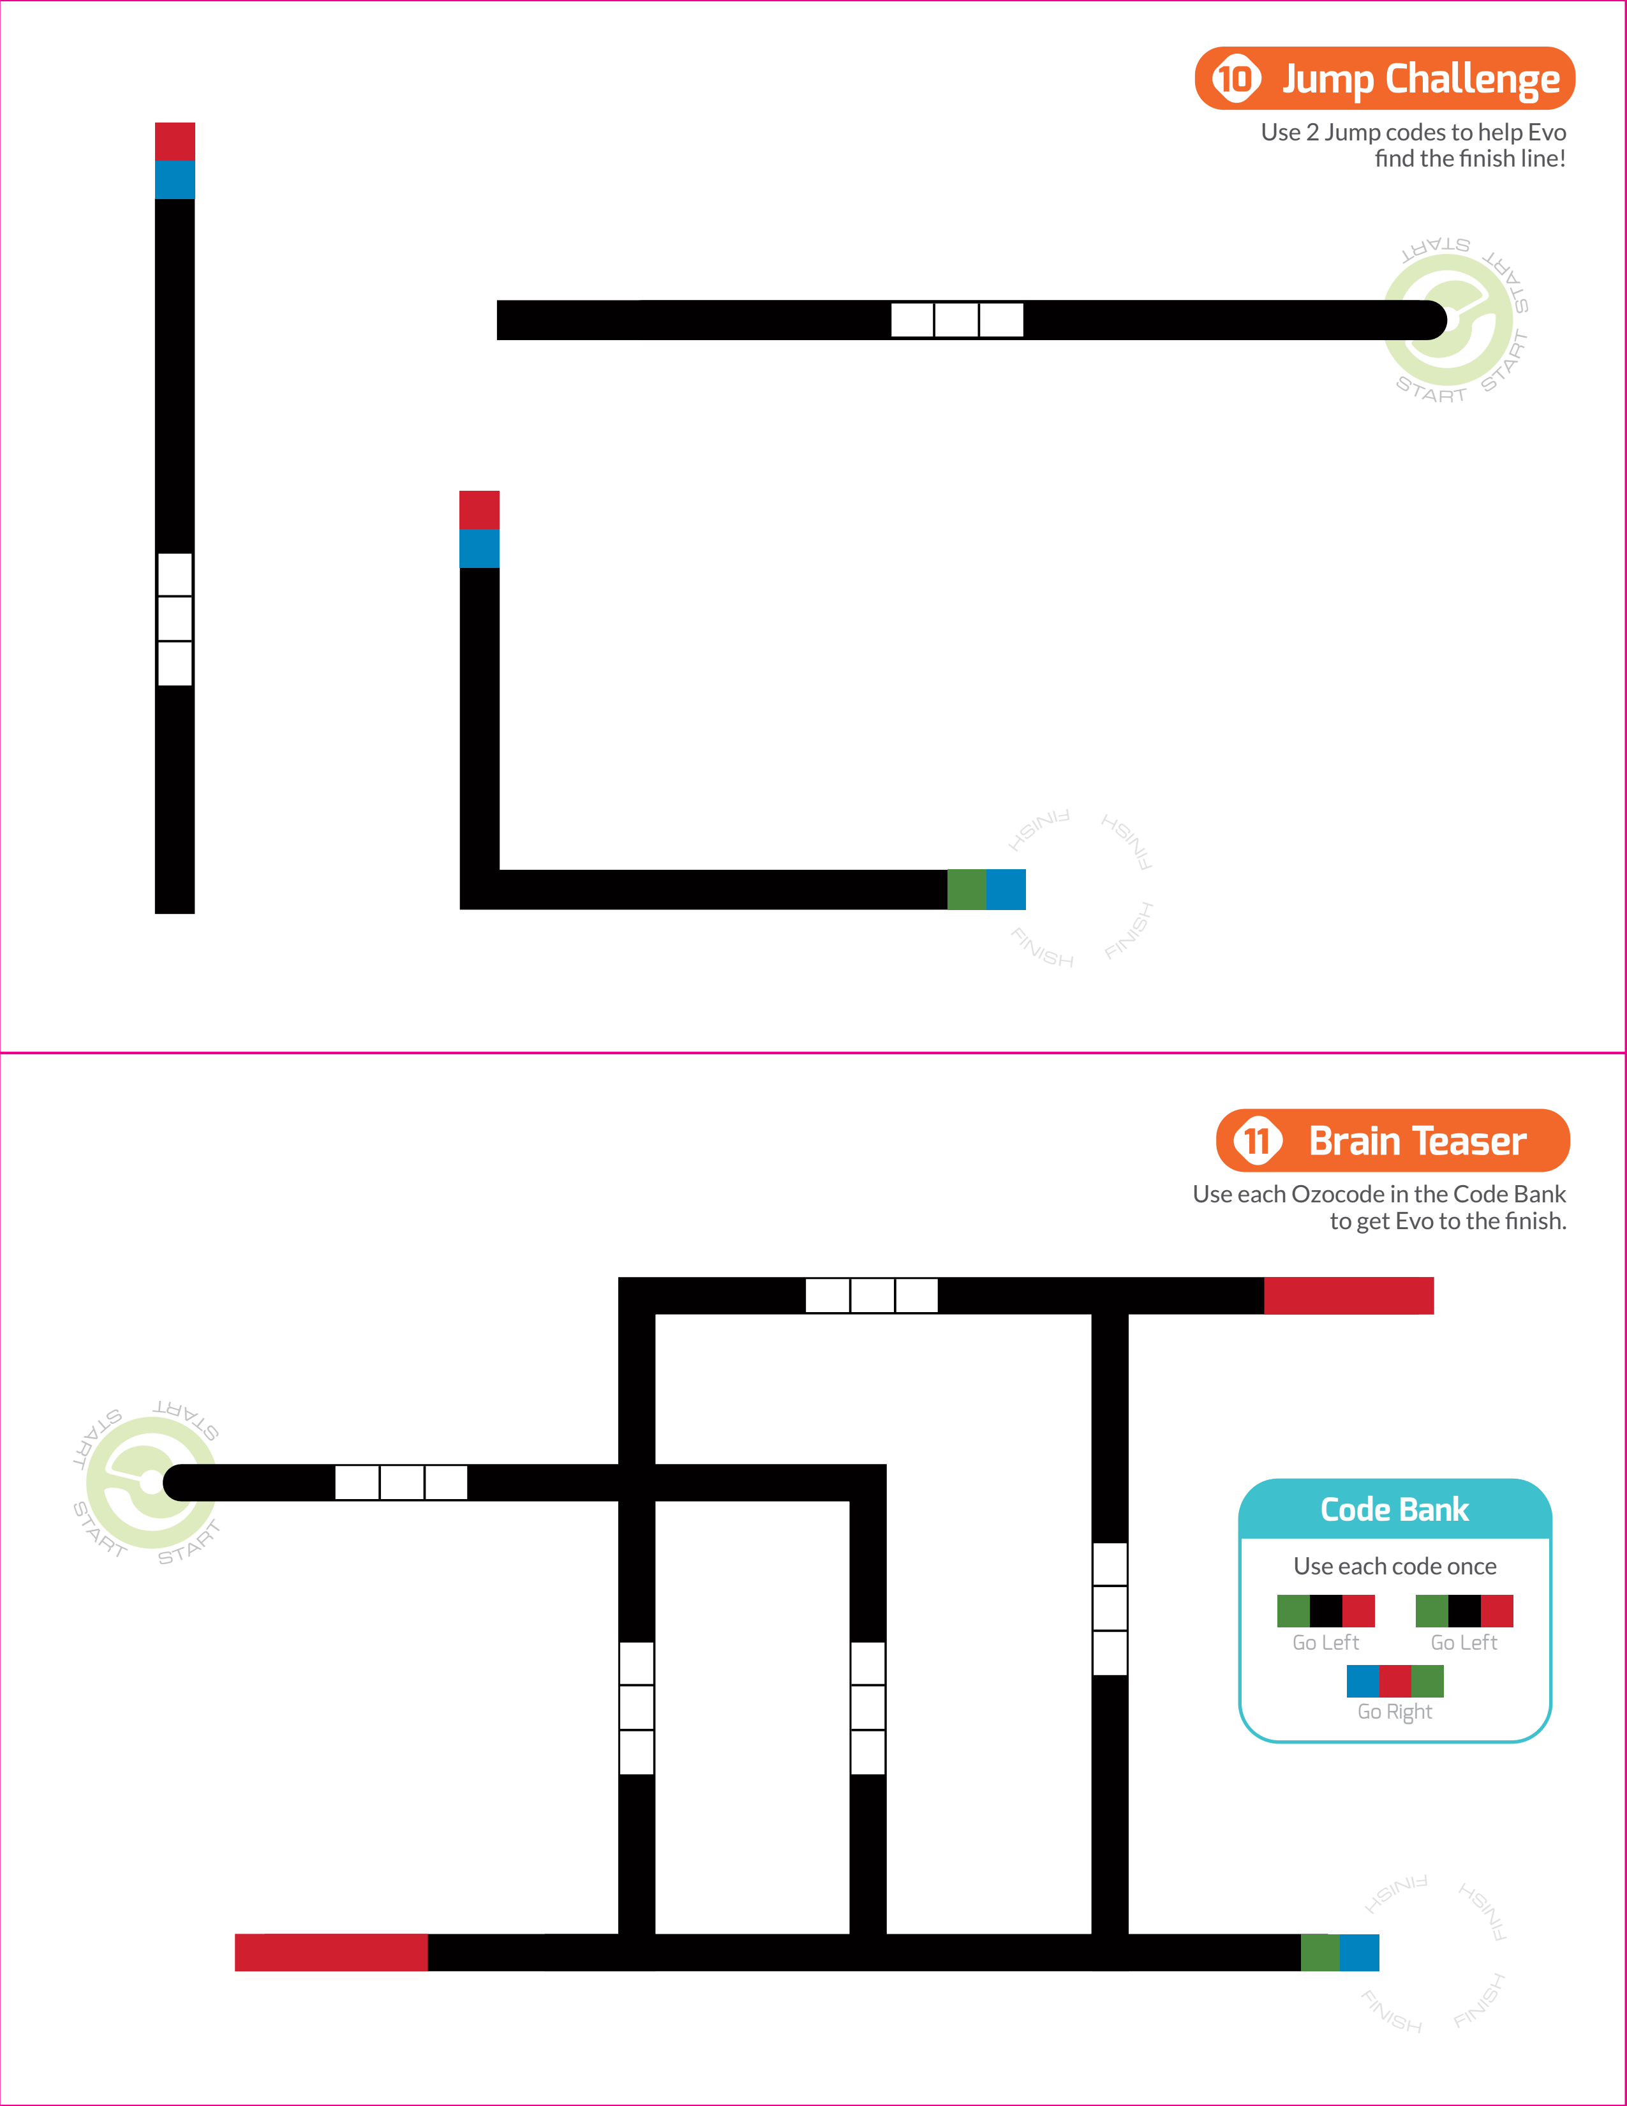

Intro to Lightbot Procedures and Functions
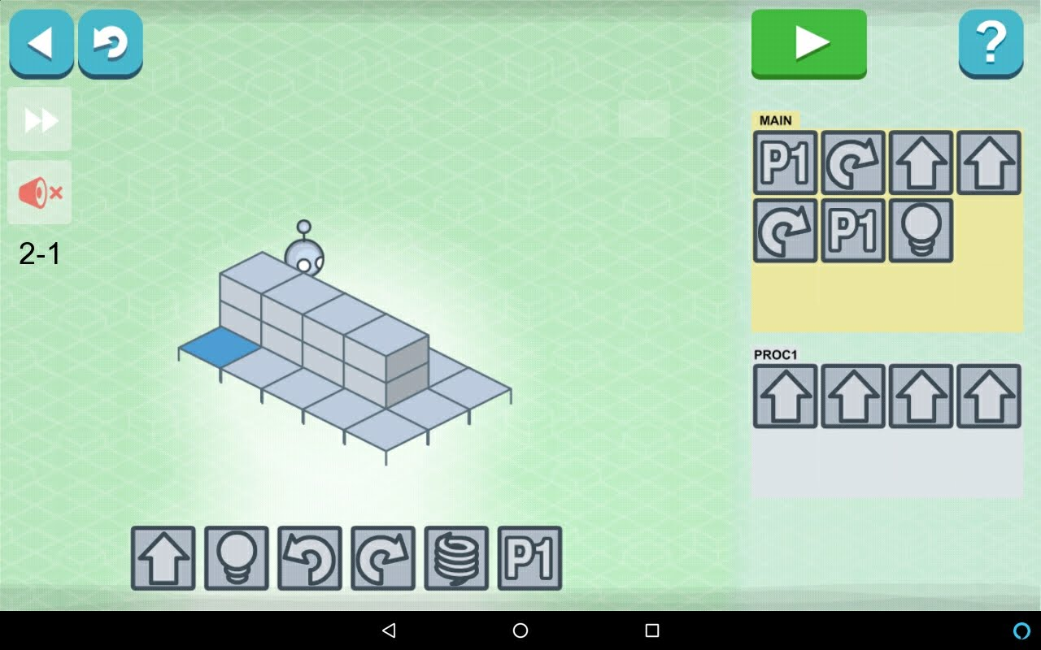

Day 3 (Wednesday)

Goals for Day 3 (Wednesday)
- Use OzoBlockly to program the Evo with a visual programming language
- Learn how to use loops to program repetitive behavior
- Learn how to reuse code with functions
- Learn how to store information with variables

Intro to OzoBlockly Editor (ozoblockly.com/editor)
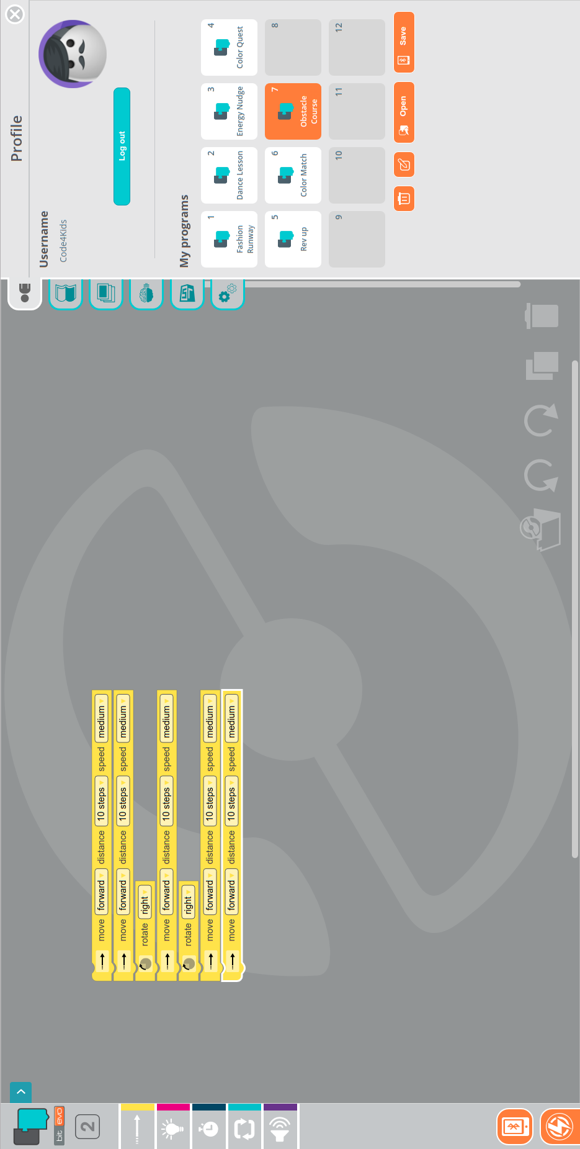

OzoBlockly Looping Example: Fashion Runway
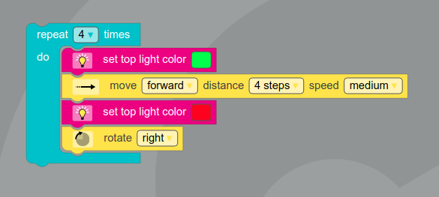

OzoBlockly Functions and Variables Example: Rev Up
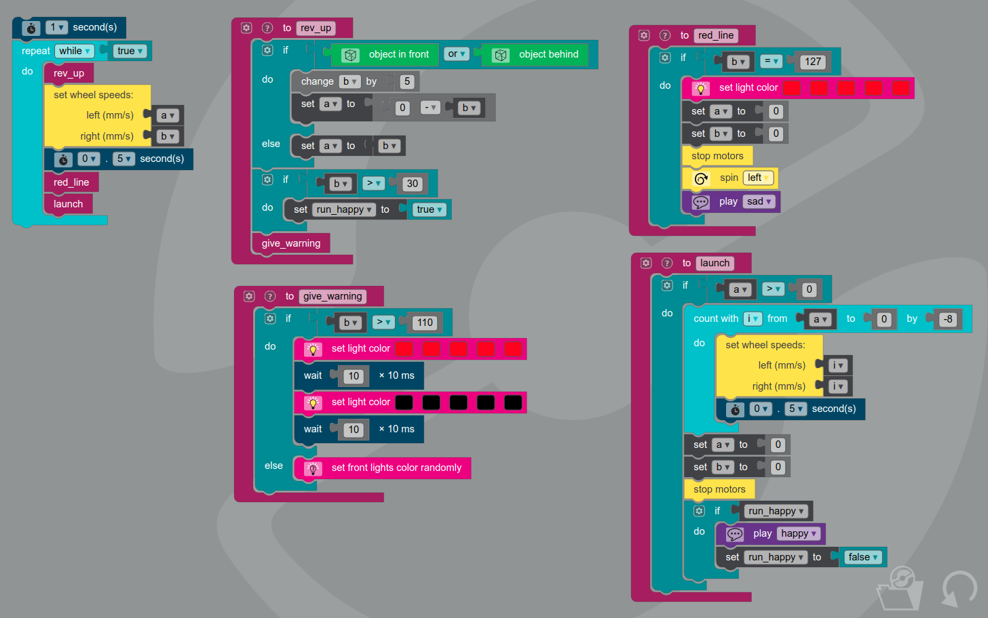

Day 4 (Thursday)

Goals for Day 4 (Thursday)
- Program the Evo to drive on its own using its color and proximity sensors
- Program the Evo to have different behavior depending on the “traffic rules” at the time
- Create your own program to make the Evo do whatever you want!

Driver-Less Car Course
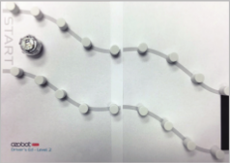

Traffic Rules Course
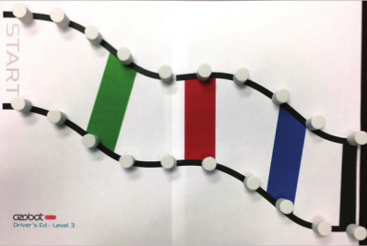

Extra OzoBlockly Activity #1: Jumping (Level 4 OzoBlockly)
- Program Evo to follow the line until it finds a line end
- At each line end, perform a “jump” by moving forward until line is found
- Count the number of jumps performed, and end the program after four jumps
- Set the top light to green while following a line, and red when “jumping”
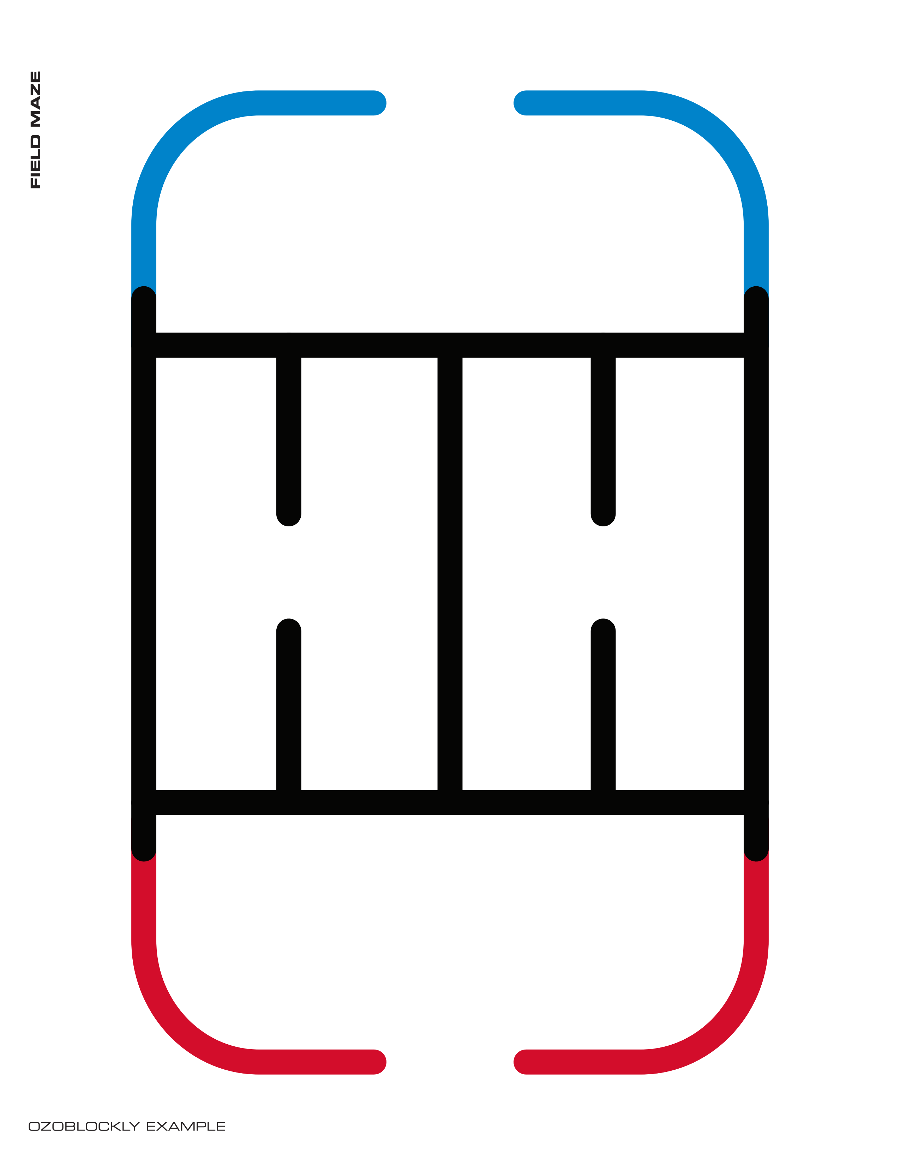

Extra Ozoblockly Activity #2: Piano (OzoBlockly Level 3)
- Set Evo to follow lines and always go straight at intersections
- Play a musical note depending on the color underneath
- Be sure to calibrate Evo to your paper before running the program!
- To play Frere Jacques, use the chart below
Red | Green | Blue | Black | Else...
Play note C | Play note D | Play note E | Play note F | Play note G
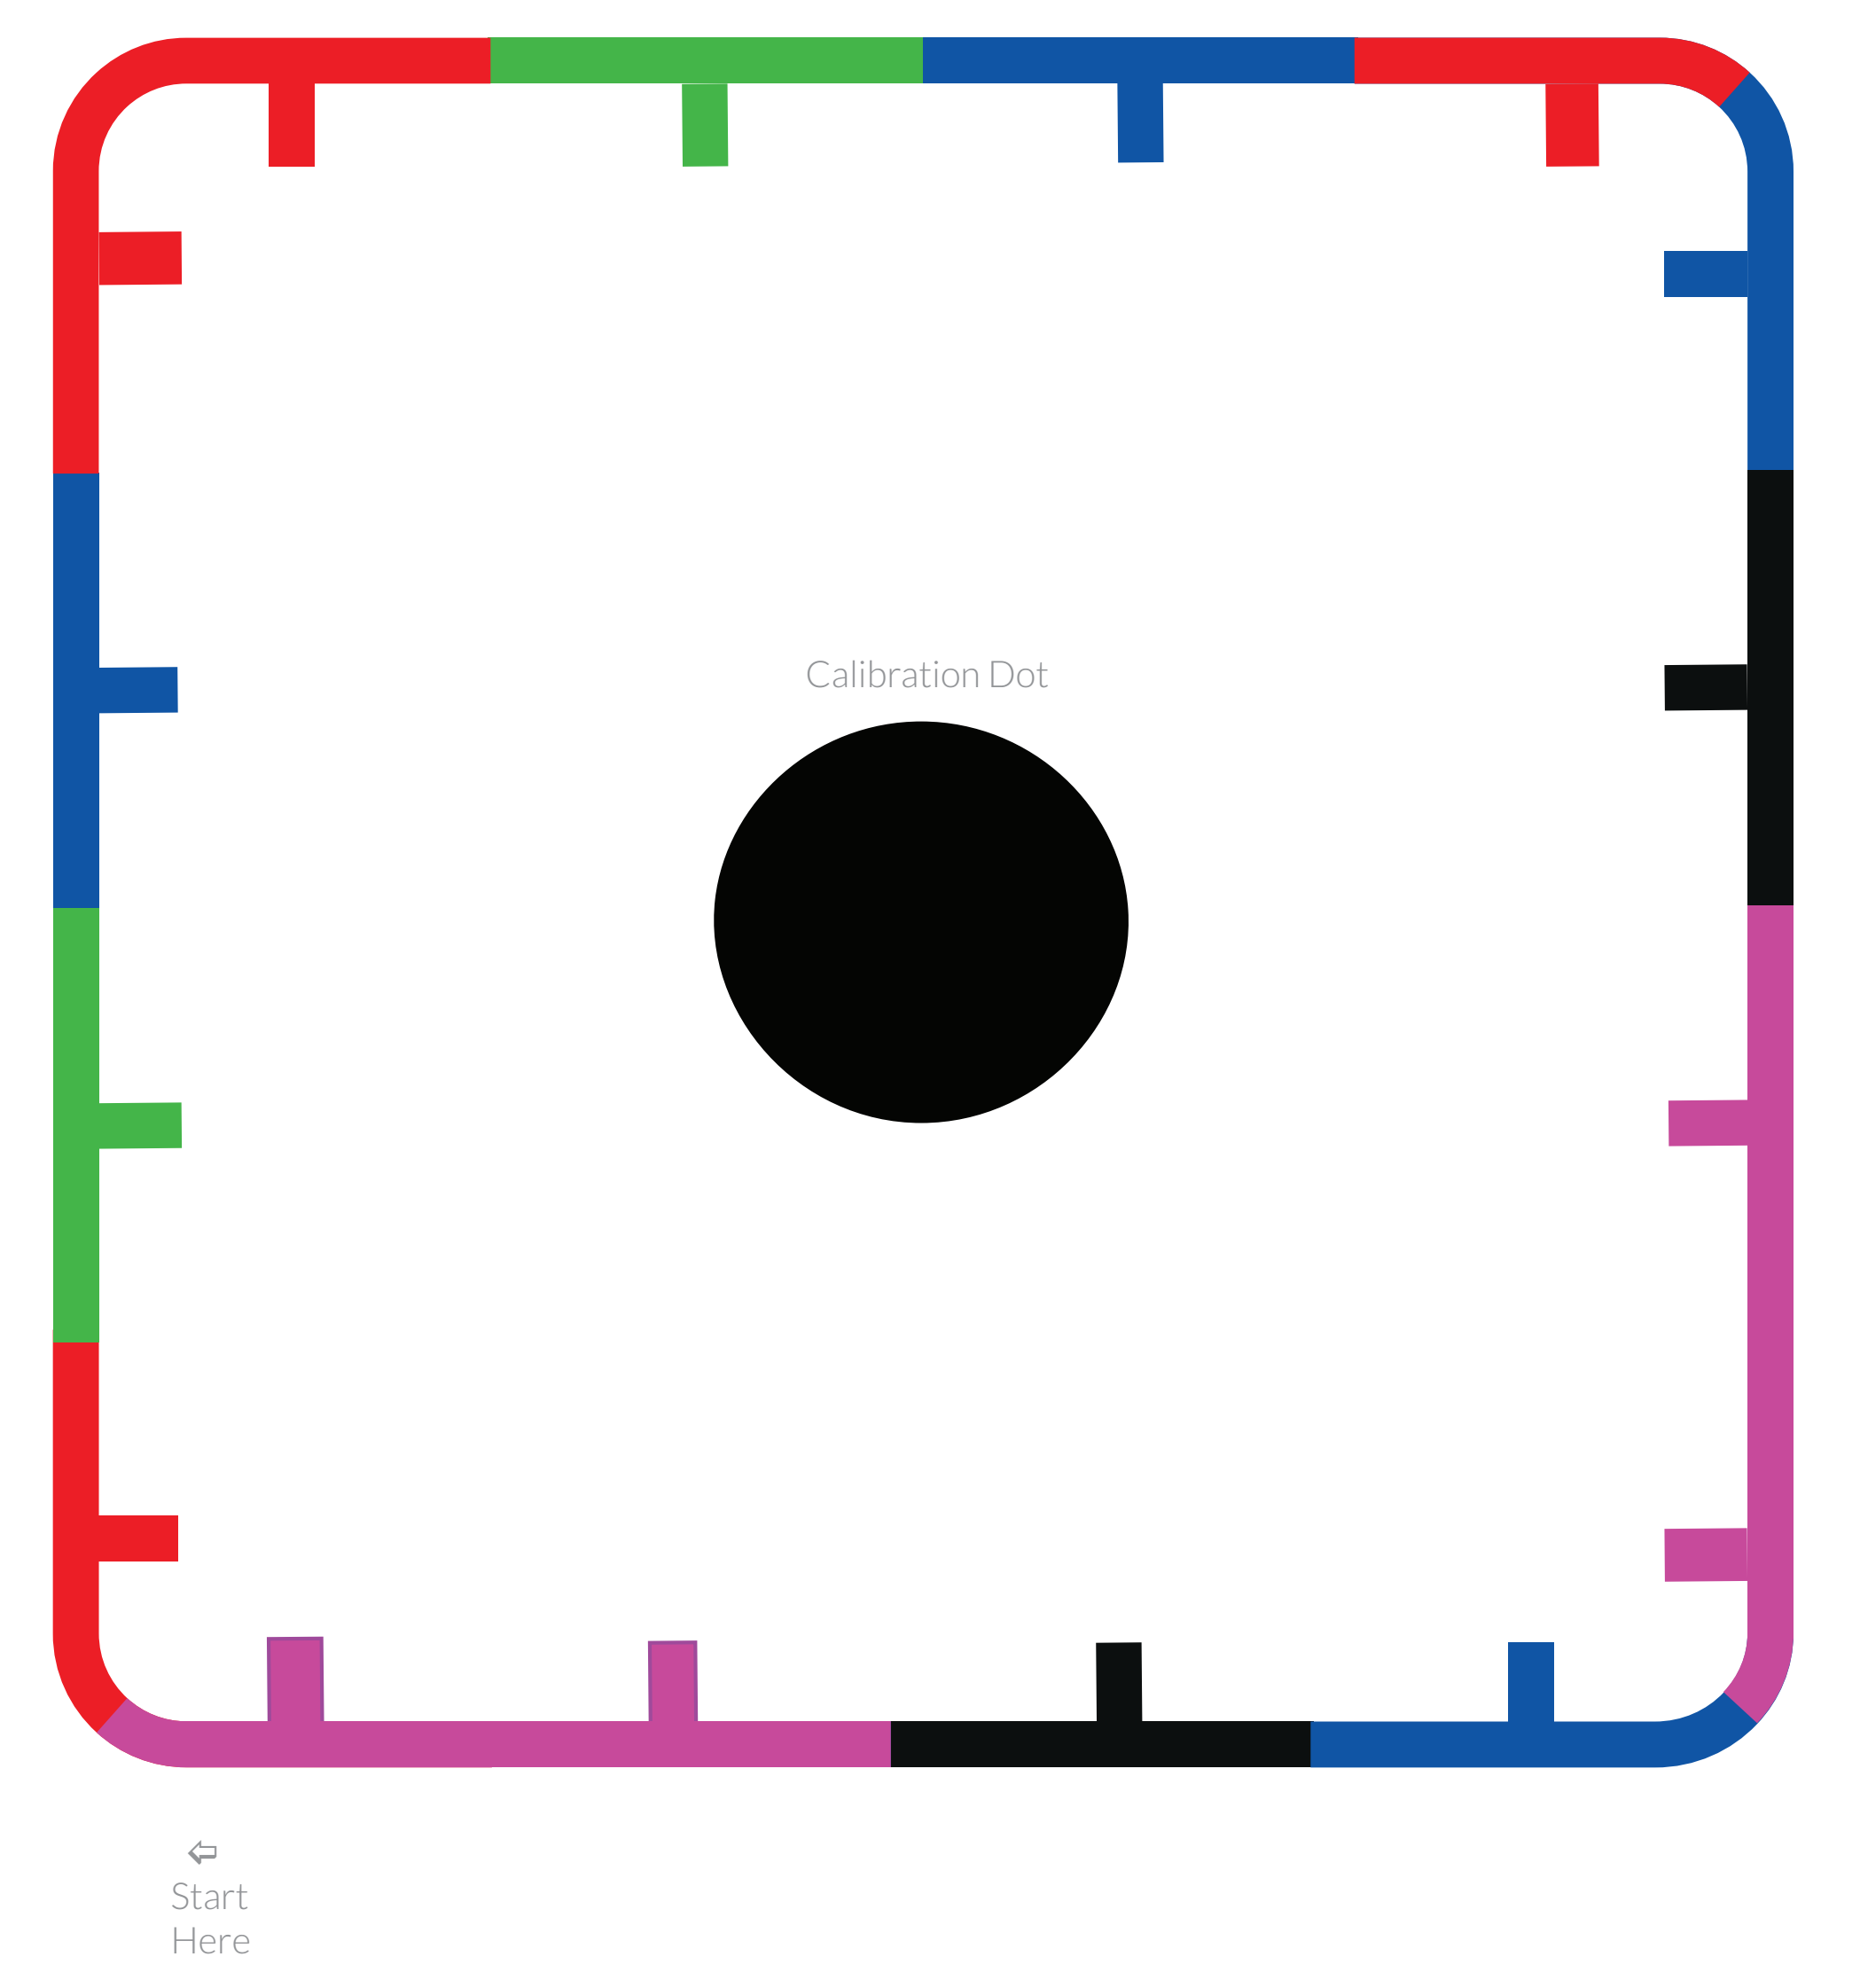

Piano Extra Credit: Use Markers to Make Your Own Color/Note Combos to Play a Song
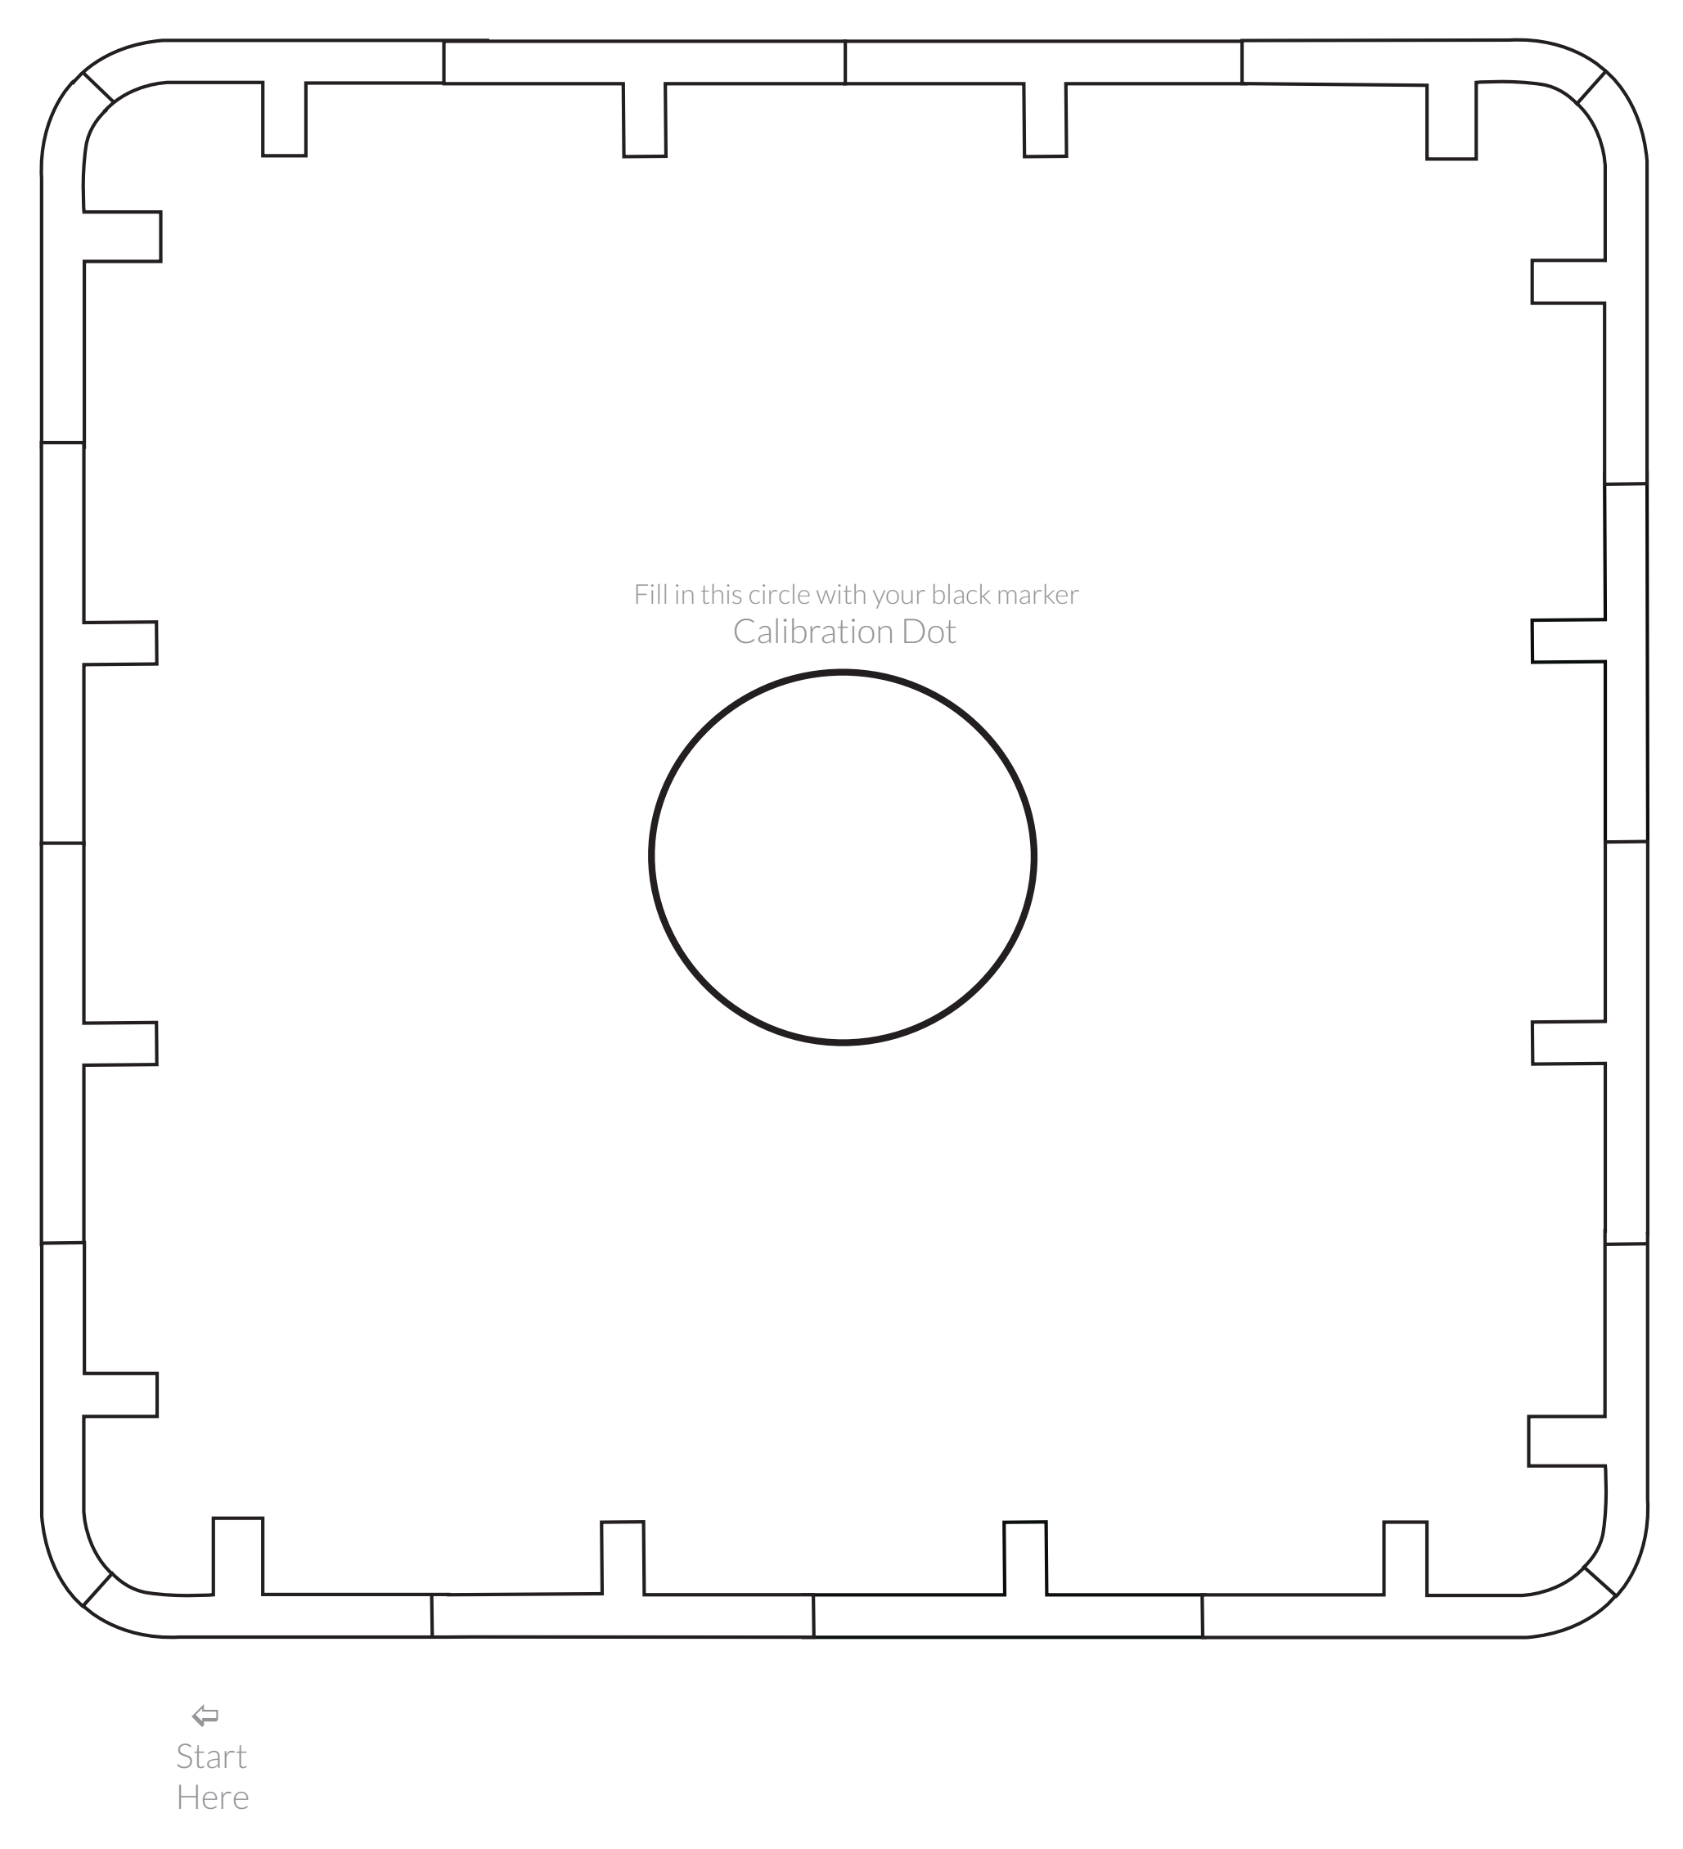

OzoBlockly Extra Activity #3: Avoid Red (OzoBlockly Level 3)
- This program runs forever
- Randomly follow the grid UNLESS the color is red
- If the color is red, turn around and go back
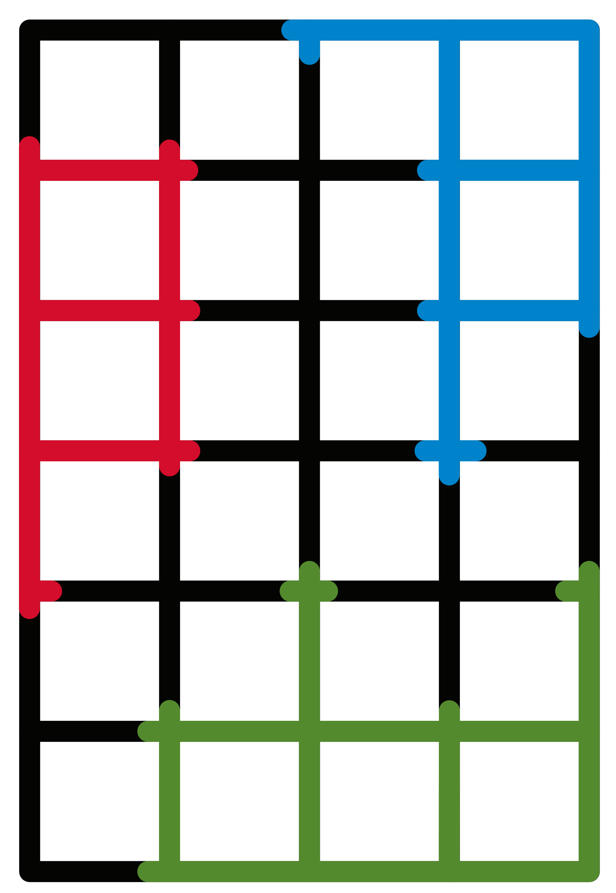
- Extra Credit: Draw images in the blank spaces between squares to tell why Evo must behave the way it does (ex: red is lava, blue is ocean, green is a field). Maybe make one color the goal and end the program there?

OzoBlockly Extra Activity #4: Snowplow
- Use the foam marshmallows or crumpled up tiny pieces of paper to represent “snow” covering the road
- Construct a plow from card stock paper and attach it to the Evo so it can push the snow away
- Create a roadway on poster board and program the Evo to navigate the roadway and clear as much snow as possible within 2 minutes
- Determine a way to compare how well the Evo did and modify your plow design or code to improve its performance


